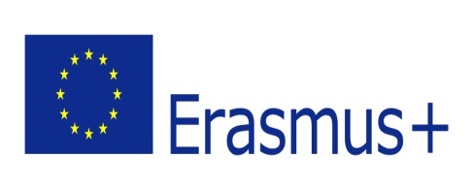
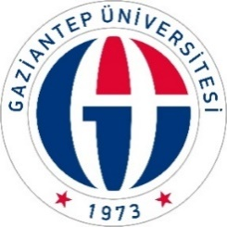

CERTIFICATE OF PARTICIPATION

It is hereby confirmed that Prof. Dr. Ali ALİOĞLU has performed Erasmus+ Staff Mobility for Training/Teaching at Üniversite adı/Ülke from 19/05/2026 to 21/05/2026.

Aurhorized Person:

Date:

Signature:

